**Dental Clinic Services System**

Software Design

By

**Kanokwan Maneerat 542115002**

**Worapun Wongkium 542115055**

Department of Software Engineering

College of Arts, Media, and Technology

Chiang Mai University

Project Adviser

______________________________

Mrs. Yun Rim Park

**Software Design**

**Revision Table**

|  |  |  |  |  |  |
| --- | --- | --- | --- | --- | --- |
| **Document Name** | **Detail** | **Status** | **Date** | **Viewable** | **Reviewer& Responsible** |
| Dental Clinic Services System-software design-ver 0.1 |  | Draft | 04/06/2014 | 04/06/2014 | Kanokwan & Worapun |
|  |  |  |  |  |  |
|  |  |  |  |  |  |
|  |  |  |  |  |  |
|  |  |  |  |  |  |
|  |  |  |  |  |  |
|  |  |  |  |  |  |

Table of Contents

Chapter One: Introduction 4

1. Introduction 4

1.1 Objectives 4

1.2 Project Scope 4

Chapter Two: Overall Description 6

2. Overall Description 6

2.1 Product Perspective 6

a. Product Features 6

2.3 Design and Implementation Constraints 6

Chapter Three: System Architecture 7

3. System Architecture 7

Chapter Four: Detail Design 9

4. Detail Design 9

4.1 Class diagram 9

Chapter Five: Sequence Diagram 32

5. Sequence Diagram 32

Chapter Six: User Interface Design 45

6. User Interface Design 45

# Chapter One: Introduction

## Introduction

### 1.1 Objectives

Dental clinic service system is a web application and mobile application, which support ios7. This application is support English language for the person who is the patient, the officer or the dentist of the dental clinic furthermore it allow visitor can use. This application will reduce officers’ work and do not waste patients’ time so, patient can find anything about dental clinic information or personal information and others from it. For the visitor who want to has a dental treatment from the clinic he/she can make an appointment to the dentist through the application and also the dentist can use it for checking patients’ schedule. The Dental clinic services system is gathered most of the services in the clinic into the web application and mobile application. When the application is grouping all the services together it will be uncomplicated for dental clinic user.

This Software Requirement Specification has described in more detail of each requirement and each function that the system should have. The document includes the scope of project, product function, user characteristic, Functional Requirement, and Non-Functional Requirement.

### 1.2 Project Scope

The objective of this software requirement specification is to specify requirement to establish the application that:

* Dental clinic services system is application on web and mobile.
* Dental clinic services system on Mobile is ios application.
* Dental clinic services system supports English language.
* Dental clinic services system provides for dental clinics’ patient, officer and dentist.
* Dental clinic services system provides the appointment of patient and dentist in the website and application.
* Dental clinic services system provides the user ID for patient and dentist by dental clinic officer.

**1.3 User Classes and Characteristics**

The system divided users into 3 groups. Information and characteristics of each group are listed below.

* **Patient**

This group of person who already register for the system that receives patientID from the dental clinic, they can use the application both in web application and mobile application. Patient uses patientID to login. The patient is able to:

* + Patient can receive the pateintID from the dental clinic
  + Patient can login to the website and the mobile application
  + Patient can logout from the website and mobile application
  + Patient can view his/her appointment in the patient schedule
  + Patient can view all appointment in the dental clinic schedule
* **Officer**

This group of person who has the highest privilege in the system. So they gain the management function for maintaining the system. Officer is able to:

* + Officer can login to the website by using officerID
  + Officer can logout from the website
  + Officer can provide the pateintID, dentistID to both users
  + Officer can add appointment into the dental clinic schedule
  + Officer can edit appointment in the dental clinic schedule
  + Officer can delete appointment in the dental clinic schedule
* **Dentist**

This group of person who has the highest privilege in the system. So they gain the management function for maintaining the system. Dentist is able to:

* + Dentist can login to the website by using dentistID
  + Dentist can logout from the website
  + Dentist can view his/her appointment in the dentist schedule
  + Dentist can view all appointment in the dental clinic schedule

**1.4 Operation Environment**

Dental clinic services system use web services technology and ios technology. All the characters must have the Internet connection. For patient must have smartphone which supports ios operation version 7.

**1.5 Acronyms and Definitions Acronyms**

DCSS =Dental clinic services system

PMP = Project Management Plan

* 1. SDD = Software Design Document
  2. SRS = Software Requirment Specification
  3. URS = User Requirement Specification
  4. SRS = Software Requirement Specification
  5. UC = Use Case
  6. AD = Activity Diagram

# Chapter Two: Overall Description

## Overall Description

### 2.1 Product Perspective

The Dental clinic services system is a mobile application base on ios and a web application. So this application helps users save their time to has a contact with the dental clinic by providing features such as First, making an appointment by your own. Second, unnecessary to contain appointment card by using the qr code which that provide by the officer of the clinic for the first time registered. Third, reduce officers’ work that is does not to call to any patient about the appointment. This application is grouping most of dental clinics' services into one application.

### Product Features

The dental clinic services system is divided the feature into six features. Each of features will create a step by a step suit by priority. The following list is a description of each part in more detail.

### 2.3 Design and Implementation Constraints

List of project constraints:

* The application work on only ios version7
* The application is requires the Internet connection.
* The application provides to user who is already registering in the system and also who is not.

# Chapter Three: System Architecture

## 3. System Architecture

# Chapter Four: Detail Design

## 4. Detail Design

### 4.1 Class diagram

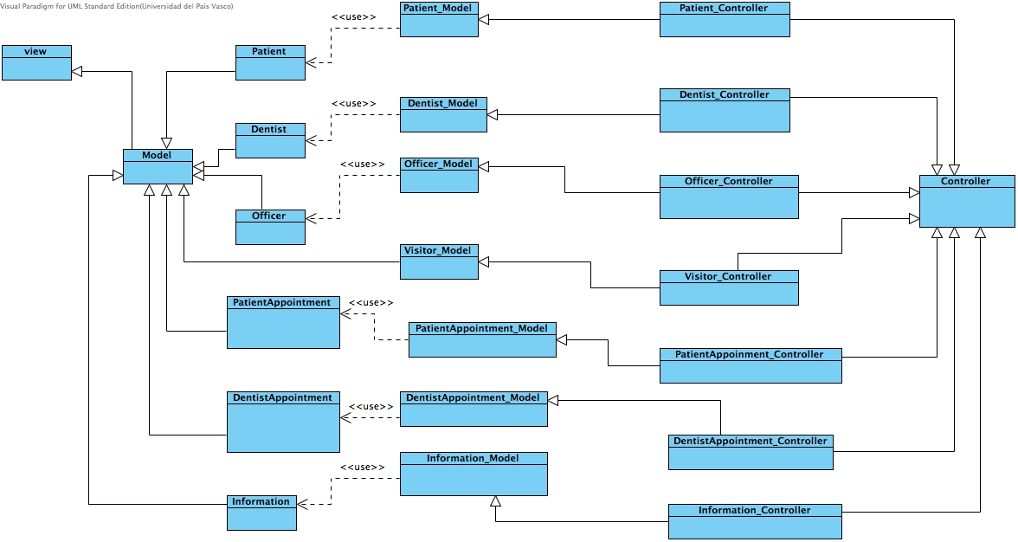

4.2 Class Diagram Description

CD-01, URS

Class name: Patient

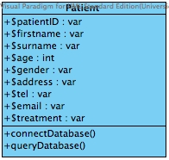

Property

|  |  |  |  |
| --- | --- | --- | --- |
| ID | Name | Description | Remark |
| 1 | $patientID | Identify the patientID that is stored in the database. | Type: varchar |
| 2 | $firstname | Declare variable for identify the patients’ firstname that store in the database. | Type: varchar |
| 3 | $surname | Declare variable for identify the patients’ surname that store in the database. | Type: varchar |
| 4 | $age | Declare variable for identify the patients’ age that store in the database. | Type: int |
| 5 | $gender | Declare variable for identify the patients’ gender that store in the database. | Type: varchar |
| 6 | $address | Declare variable for identify the patient’s address that store in the database. | Type: varchar |
| 7 | $tel | Declare variable for identify the patients’ tel that store in the database. | Type: varchar |
| 8 | $email | Declare variable for identify the patients’email that store in the database. | Type: varchar |
| 9 | $treatment | Declare variable for identify the patients’ dental treatment that store in the database. | Type: varchar |

Method

|  |  |  |  |
| --- | --- | --- | --- |
| ID | Name | Description | Remark |
| 1 | connectDatabse() | connect with the dental clinic database. | - |
| 2 | queryDatabase() | Method uses to query the data from the dental clinic database. | - |

CD-02, URS

Class name: Patient_Model

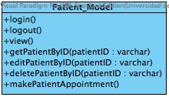

Property

|  |  |  |  |
| --- | --- | --- | --- |
| ID | Name | Description | Remark |
| - | - | - | - |

Method

|  |  |  |  |  |
| --- | --- | --- | --- | --- |
| ID | Name | | Description | Remark |
| 1 | login() | | Method uses to login for patient. | - |
| 2 | logout() | | Method uses to logout for patient. | - |
| 3 | view() | | Method uses to view any page which allow for patient | - |
| 4 | getPatientByID() | | Method uses to get patient by using patients’ id. | - |
| 5 | editPatientByID() | | Method uses to edit patient information by using patients’ id. | - |
| 6 | | deletePatientByID() | Method uses to delete patient by using patients’ id. | - |
| 7 | | makePatientAppointment() | Method uses to make new patient appointment. | - |

CD-03,URS

Class name: Patient_Controller

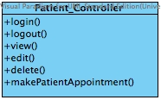

Property

|  |  |  |  |
| --- | --- | --- | --- |
| ID | Name | Description | Remark |
| - | - | - | - |

Method

|  |  |  |  |
| --- | --- | --- | --- |
| ID | Name | Description | Remark |
| 1 | login() | Method uses to login for patient. | - |
| 2 | logout() | Method uses to logout for patient. | - |
| 3 | view() | Method uses to view any page which allow for patient | - |
| 4 | edit() | Method uses to edit patient personal information into the database. |  |
| 5 | delete() | Method uses to delete patient form the database. | - |
| 6 | makePatientAppointment() | Method uses to make new patient appointment. | - |

CD-04, URS

Class name: Officer

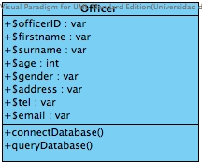

Property

|  |  |  |  |
| --- | --- | --- | --- |
| ID | Name | Description | Remark |
| 1 | $officerID | Declare variable for identify the officerID that store in the database. | Type: varchar |
| 2 | $firstname | Declare variable for identify the officers’ firstname that store in the database. | Type: varchar |
| 3 | $surname | Declare variable for identify the officers’ surname that store in the database. | Type: varchar |
| 4 | $age | Declare variable for identify the officers’ age that store in the database. | Type: int |
| 5 | $gender | Declare variable for identify the officers’ gender that store in the database. | Type: varchar |
| 6 | $address | Declare variable for identify the officers’ address that store in the database. | Type: varchar |
| 7 | $tel | Declare variable for identify the officers’ tel that store in the database. | Type: varchar |
| 8 | $email | Declare variable for identify the officers’email that store in the database. | Type: varchar |

Method

|  |  |  |  |
| --- | --- | --- | --- |
| ID | Name | Description | Remark |
| 1 | connectDatabse() | Method uses to connect with the dental clinic database. | - |
| 2 | queryDatabase() | Method uses to query the data from the dental clinic database. | - |

CD-05,URS

Class name: Officer_Model

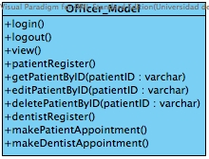

Property

|  |  |  |  |
| --- | --- | --- | --- |
| ID | Name | Description | Remark |
| - | - | - | - |

Method

|  |  |  |  |  |
| --- | --- | --- | --- | --- |
| ID | Name | Description | | Remark |
| 1 | login() | Method uses to login for patient. | | - |
| 2 | logout() | Method uses to logout for patient. | | - |
| 3 | view() | Method uses to view any page which allow for patient | | - |
| 4 | patientRegister() | Method uses to register patient into the database. | | - |
| 4 | getPatientByID() | Method uses to get patient by using patients’ id. | | - |
| 5 | editPatientByID() | Method uses to edit patient information by using patients’ id. | | - |
| 6 | deletePatientByID() | Method uses to delete patient by using patients’ id. | | - |
| 8 | dentistRegister() | Method uses to register dentist into the database. | | - |
| 9 | makePatientAppointment() | Method uses to make new patient appointment. | | - |
| 10 | makeDentistAppointment() | | Method uses to make new dentist appointment. | - |

CD-06,URS

Class name: Officer_Controller

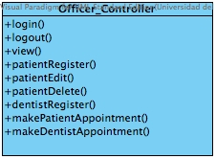

Property

|  |  |  |  |
| --- | --- | --- | --- |
| ID | Name | Description | Remark |
| - | - | - | - |

Method

|  |  |  |  |
| --- | --- | --- | --- |
| ID | Name | Description | Remark |
| 1 | login() | Method uses to login for patient. | - |
| 2 | logout() | Method uses to logout for patient. | - |
| 3 | view() | Method uses to view any page which allow for patient | - |
| 4 | patientRegister() | Method uses to register patient into the database. | - |
| 5 | patientEdit() | Method uses to edit patient information. | - |
| 6 | patientDelete () | Method uses to delete patient. | - |
| 7 | dentistRegister() | Method uses to register dentist into the database. | - |
| 8 | makePatientAppointment() | Method uses to make new patient appointment. | - |
| 9 | makeDentistAppointment() | Method uses to make new dentist appointment. | - |

CD-07,URS

Class name: Visitor_Model

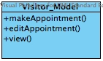

Property

|  |  |  |  |
| --- | --- | --- | --- |
| ID | Name | Description | Remark |
| - | - | - | - |

Method

|  |  |  |  |
| --- | --- | --- | --- |
| ID | Name | Description | Remark |
| 1 | makeAppointment() | Method uses to make new appointment for visitor . | - |
| 2 | editAppointment() | Method uses to edit the visitor appointment. | - |
| 3 | view() | Method uses to view any page which allow for officer | - |

CD-08,URS

Class name: Visitor_Controller

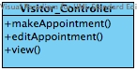

Property

|  |  |  |  |
| --- | --- | --- | --- |
| ID | Name | Description | Remark |
| - | - | - | - |

Method

|  |  |  |  |
| --- | --- | --- | --- |
| ID | Name | Description | Remark |
| 1 | makeAppointment() | Method uses to make new appointment for visitor . | - |
| 2 | editAppointment() | Method uses to edit the visitor appointment. | - |
| 3 | view() | Method uses to view any page which allow for officer | - |

CD-09,URS

Class name: Dentist

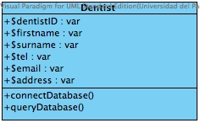

Property

|  |  |  |  |
| --- | --- | --- | --- |
| ID | Name | Description | Remark |
| 1 | $dentistID | Declare variable for identify the dentistID that store in the database. | Type: varchar |
| 2 | $firstname | Declare variable for identify the dentists’ firstname that store in the database. | Type: varchar |
| 3 | $surname | Declare variable for identify the dentists’ surname that store in the database. | Type: varchar |
| 4 | $address | Declare variable for identify the dentists’ address that store in the database. | Type: varchar |
| 5 | $tel | Declare variable for identify the dentists’ tel that store in the database. | Type: varchar |
| 6 | $email | Declare variable for identify the dentists’email that store in the database. | Type: varchar |

Method

|  |  |  |  |
| --- | --- | --- | --- |
| ID | Name | Description | Remark |
| 1 | connectDatabse() | Method uses to connect with the dental clinic database. | - |
| 2 | queryDatabase() | Method uses to query the data from the dental clinic database. | - |

CD-10,URS

Class name: Dentist_Model

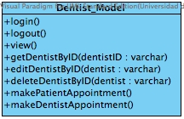

Property

|  |  |  |  |
| --- | --- | --- | --- |
| ID | Name | Description | Remark |
| - | - | - | - |

Method

|  |  |  |  |  |
| --- | --- | --- | --- | --- |
| ID | Name | | Description | Remark |
| 1 | login() | | Method uses to login for patient. | - |
| 2 | logout() | | Method uses to logout for patient. | - |
| 3 | view() | | Method uses to view any page which allow for patient | - |
| 4 | patientRegister() | | Method uses to register patient into the database. | - |
| 5 | getDentistByID() | | Method uses to get dentist by using dentists’ id. | - |
| 6 | editDentistByID() | | Method uses to edit dentist information by using dentists’ id. | - |
| 7 | deleteDentistByID() | | Method uses to delete dentist by using dentists’ id. | - |
| 8 | | makePatientAppointment() | Method uses to make new patient appointment. | - |
| 9 | | makeDentistAppointment() | Method uses to make new dentist appointment. | - |

CD-11,URS

Class name: Dentist_Controller

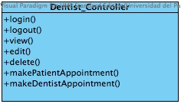

Property

|  |  |  |  |
| --- | --- | --- | --- |
| ID | Name | Description | Remark |
| - | - | - | - |

Method

|  |  |  |  |
| --- | --- | --- | --- |
| ID | Name | Description | Remark |
| 1 | login() | Method uses to login for patient. | - |
| 2 | logout() | Method uses to logout for patient. | - |
| 3 | view() | Method uses to view any page which allow for patient | - |
| 4 | edit() | Method uses to edit dentistinformation. | - |
| 5 | delete () | Method uses to delete dentist. | - |
| 6 | makePatientAppointment() | Method uses to make new patient appointment. | - |
| 7 | makeDentistAppointment() | Method uses to make new dentist appointment. | - |

CD-12,URS

Class name: PatientAppointment

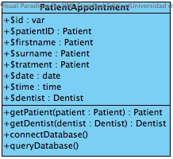

Property

|  |  |  |  |
| --- | --- | --- | --- |
| ID | Name | Description | Remark |
| 1 | $id | Declare variable for identify the patient appointment id that store in the database. | Type: varchar |
| 2 | $patientID | Declare variable for identify the patients’ id that store in the database. | Type:varchar |
| 2 | $firstname | Declare variable for identify the patients’ firstname that store in the database. | Type: Patient |
| 3 | $surname | Declare variable for identify the patients’ surname that store in the database. | Type: Patient |
| 4 | $treatment | Declare variable for identify the patients’ dental treatment that store in the database. | Type: Patient |
| 5 | $date | Declare variable for identify the patients’ appointment date that store in the database. | Type: date |
| 6 | $time | Declare variable for identify the patient’s appointment time that store in the database. | Type: time |
| 7 | $dentist | Declare variable for identify the dentist that store in the database. | Type: Dentist |

Method

|  |  |  |  |
| --- | --- | --- | --- |
| ID | Name | Description | Remark |
| 1 | getPateint($pateint:Pateint) | Method uses to get information from Patient class | Type:Pateint |
| 2 | getDentist($dentist:Dentist) | Method uses to get information from Patient class | Type:Dentist |
| 3 | connectDatabse() | Method uses to connect with the dental clinic database. | - |
| 4 | queryDatabase() | Method uses to query the data from the dental clinic database. | - |

CD-13,URS

Class name: PatientAppointment_Model

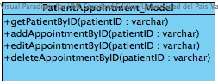

Property

|  |  |  |  |
| --- | --- | --- | --- |
| ID | Name | Description | Remark |
| - | - | - | - |

Method

|  |  |  |  |
| --- | --- | --- | --- |
| ID | Name | Description | Remark |
| 1 | getPatientByID() | Method uses to query patient from the database using patients’ id. | - |
| 2 | addAppointmentByID() | Method uses to add new appointment from patient requestedby patients’ id. | - |
| 3 | editAppointmentByID() | Method uses to edit patients’ appointment date and time by patients’ id. | - |
| 4 | deleteAppointmentByID() | Method uses to delete patients’ appointment by patients’ id. | - |

CD-014,URS

Class name: PatientAppointment_Controller

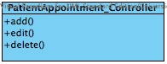

Property

|  |  |  |  |
| --- | --- | --- | --- |
| ID | Name | Description | Remark |
| - | - | - | - |

Method

|  |  |  |  |
| --- | --- | --- | --- |
| ID | Name | Description | Remark |
| 1 | add () | Method uses to add new appointment by patient. | - |
| 2 | edit () | Method uses to edit patients’ appointment. | - |
| 3 | delete() | Method uses to delete patient appointment. | - |

CD-015,URS

Class name: DentistAppointment

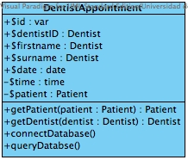

Property

|  |  |  |  |
| --- | --- | --- | --- |
| ID | Name | Description | Remark |
| 1 | $id | Declare variable for identify the dentist appointment id that store in the database. | Type: varchar |
| 2 | $dentistID | Declare variable for identify the dentist’ id that store in the database. | Type: Dentist |
| 2 | $firstname | Declare variable for identify the dentists’ firstname that store in the database. | Type: Dentist |
| 3 | $surname | Declare variable for identify the dentists’ surname that store in the database. | Type: Dentist |
| 5 | $date | Declare variable for identify the dentists’ appointment date that store in the database. | Type: date |
| 6 | $time | Declare variable for identify the dentists’s appointment time that store in the database. | Type: time |
| 7 | $patient | Declare variable for identify the patient that store in the database. | Type: Patient |

Method

|  |  |  |  |
| --- | --- | --- | --- |
| ID | Name | Description | Remark |
| 1 | getPateint($pateint:Pateint) | Method uses to get information from Patient class | Type:Pateint |
| 2 | getDentist($dentist:Dentist) | Method uses to get information from Patient class | Type:Dentist |
| 3 | connectDatabse() | Method uses to connect with the dental clinic database. | - |
| 4 | queryDatabase() | Method uses to query the data from the dental clinic database. | - |

CD-016,URS

Class name: DentistAppointment_Model

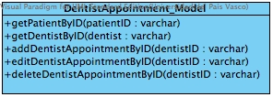

Property

|  |  |  |  |
| --- | --- | --- | --- |
| ID | Name | Description | Remark |
| - | - | - | - |

Method

|  |  |  |  |
| --- | --- | --- | --- |
| ID | Name | Description | Remark |
| 1 | getPatientByID() | Method uses to query patient from the database using patients’ id. | - |
| 1 | getDentistByID() | Method uses to query dentist from the database using dentists’ id. | - |
| 2 | addDentistAppointmentByID() | Method uses to add new dentist appointment from by dentists’ id. | - |
| 3 | editdenistAppointmentByID() | Method uses to edit dentists’ appointment by dentists’ id. | - |
| 4 | deleteDentistAppointmentByID() | Method uses to delete dentists’ appointment by dentists’ id. | - |

CD-017,URS

Class name: DentistAppointment_Controller

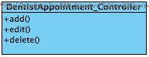

Property

|  |  |  |  |
| --- | --- | --- | --- |
| ID | Name | Description | Remark |
| - | - | - | - |

Method

|  |  |  |  |
| --- | --- | --- | --- |
| ID | Name | Description | Remark |
| 1 | add () | Method uses to add new appointment by dentist. | - |
| 2 | edit () | Method uses to edit dentists’ appointment. | - |
| 3 | delete() | Method uses to delete dentist appointment. | - |

# Chapter Five: Sequence Diagram

## 5. Sequence Diagram

**SD-01: User Login**

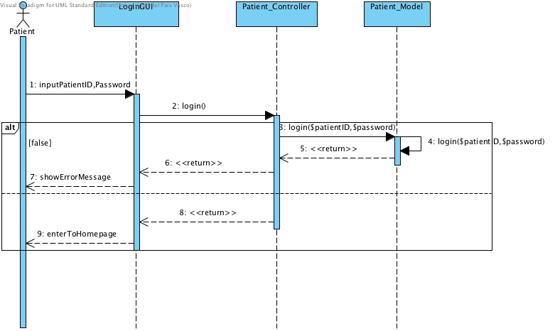

Figure 1: Patient Login

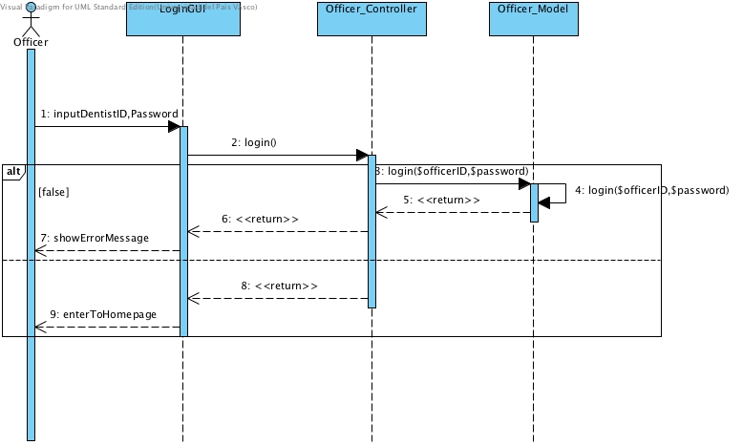Figure 2: Officer Login

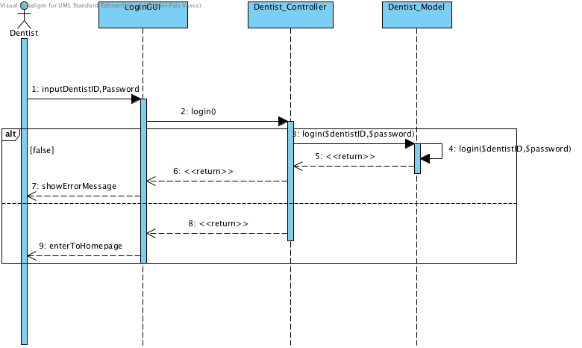

Figure 3: Dentist login

**SD-02: User Logout**

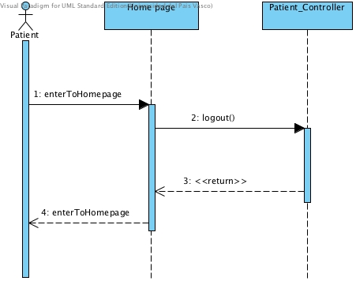

Figure 4: Patient logout

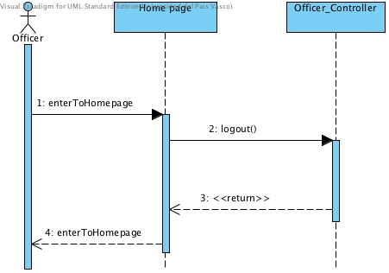

Figure 5: Officer logout

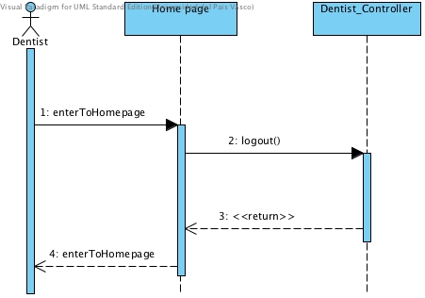

Figure 6: Dentist Logout

**SD-03: View dental clinic appointment**

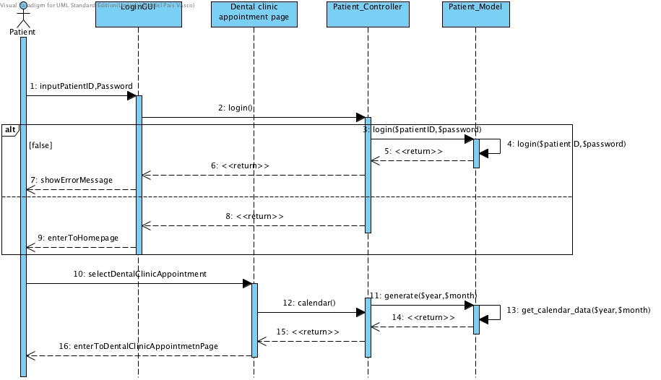

Figure 7: Patient view dental clinic appointment

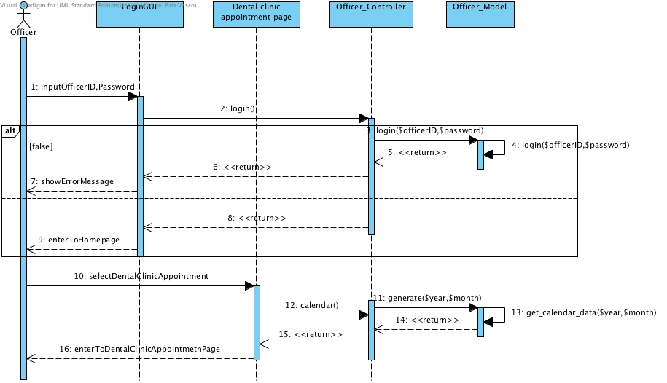

Figure 8: Officer view dental clinic appointment

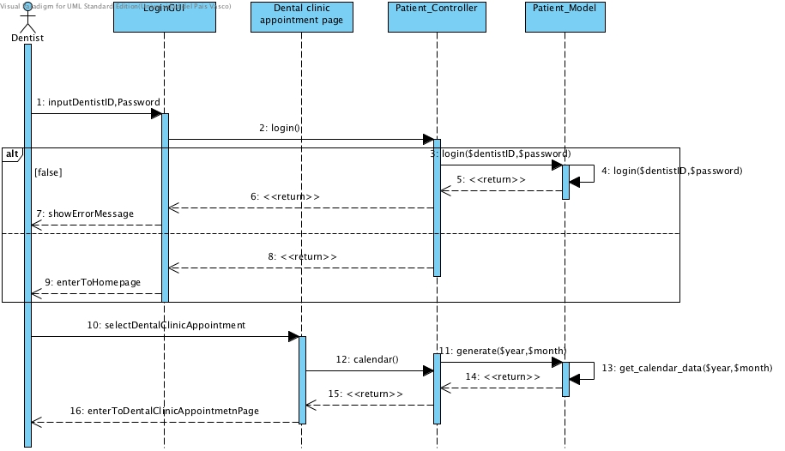

Figure 9: Dentist view dental clinic appointment

**SD-04: Patient can view his/her appointment**

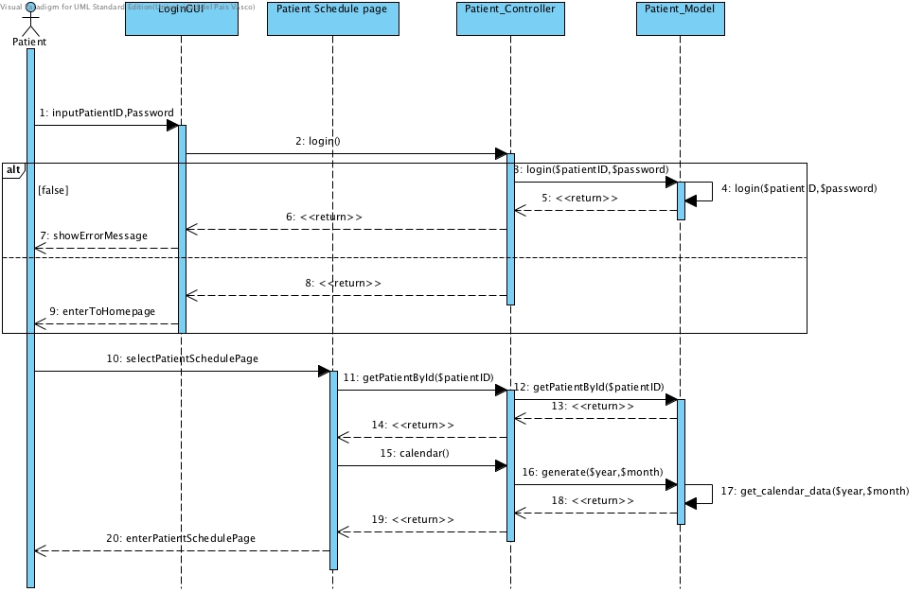

Figure 10: Patient can view his/her appointment

**SD-05: User can view dental clinic appointment**



Figure 11: Patient can view all appointment in dental clinic appointment schedule

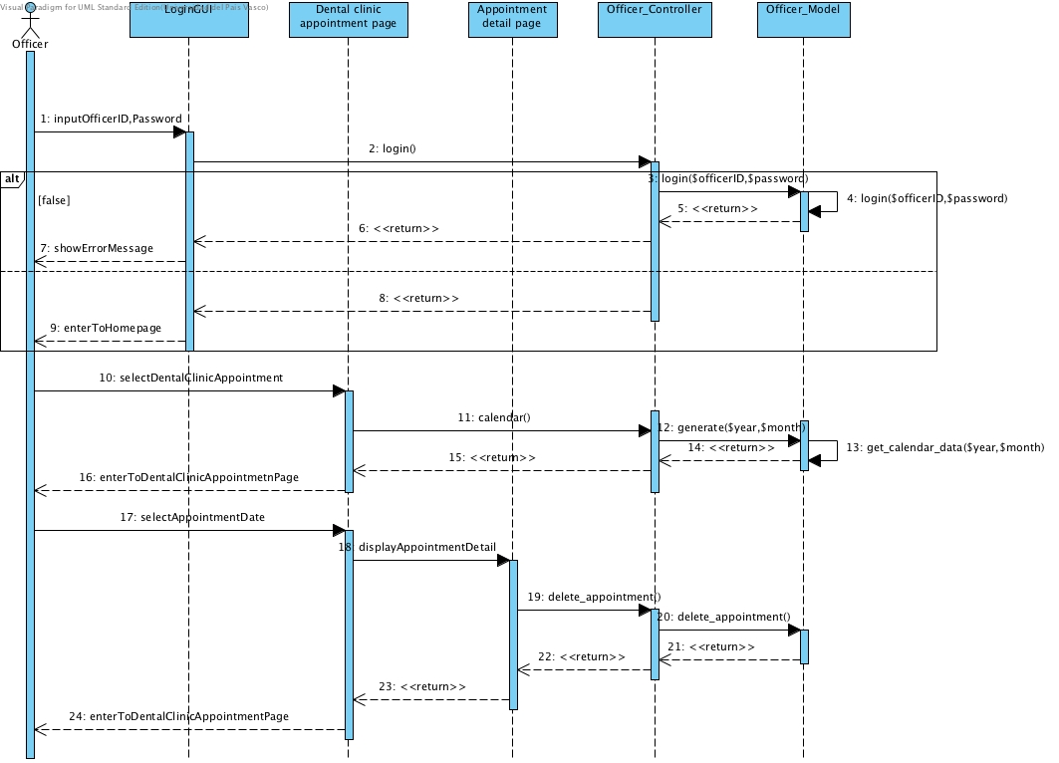

Figure 12: Officer can view all appointment in dental clinic appointment schedule



Figure 13: Dentist can view all appointment in dental clinic appointment schedule

**SD-06: Officer can create patient account**

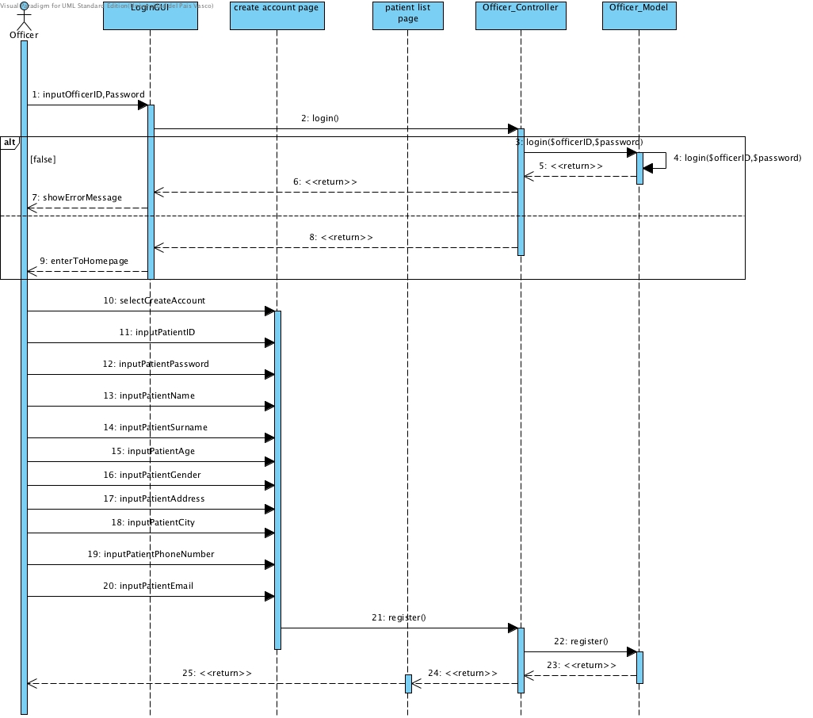Figure 14: Officer can create patient account

**SD-07: Officer can create dentist account**

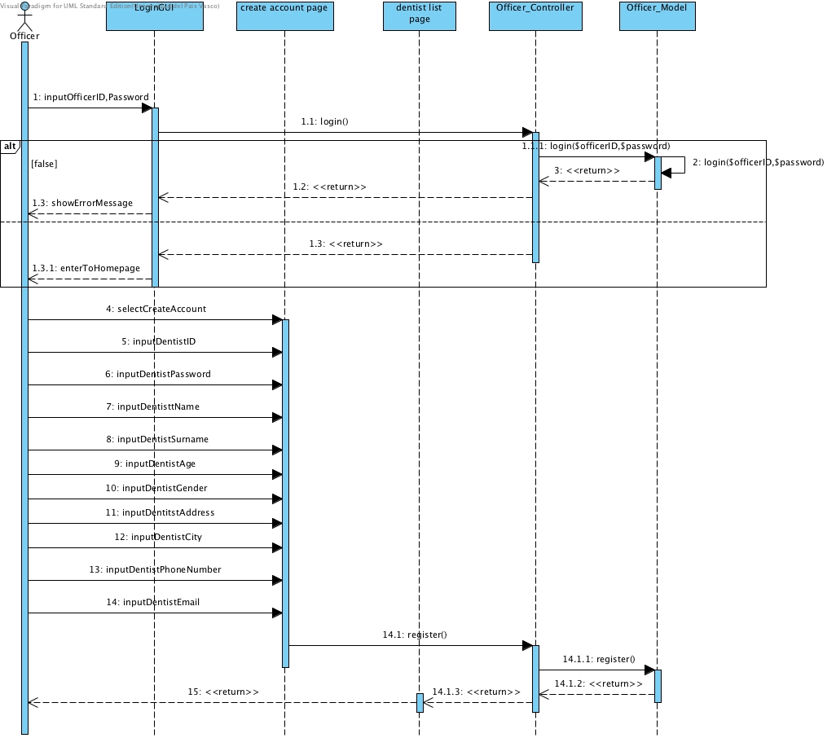

Figure 15: Officer can create dentist account

**SD-08: Officer can view all patients in the list**

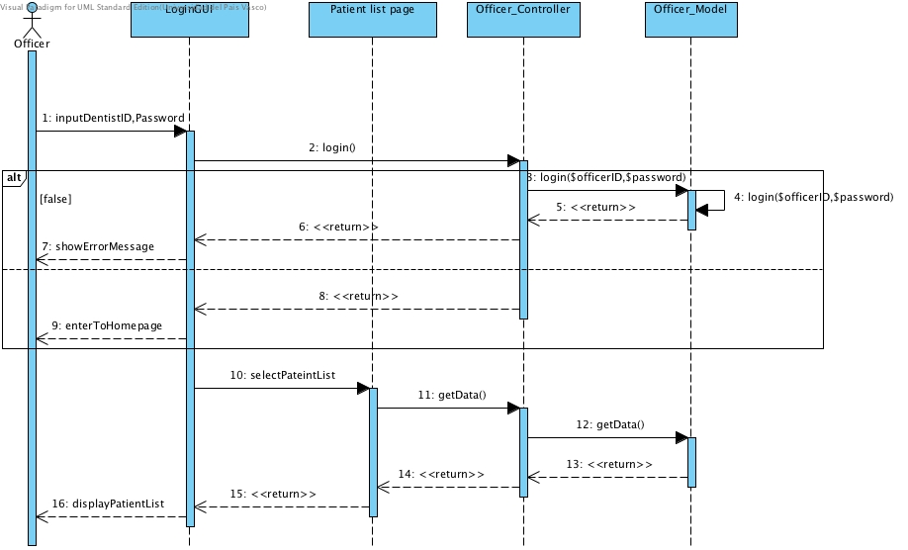

Figure 16: Officer can view all patients in the list after registered patient

**SD-09: Officer can view all dentist sin the list**

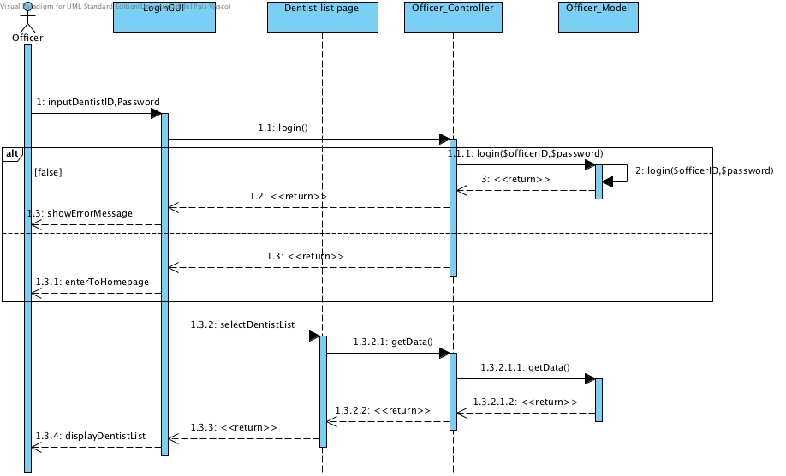

Figure 17: Officer can view all dentists in the list after registered dentist

**SD-10: Officer can add new appointment**

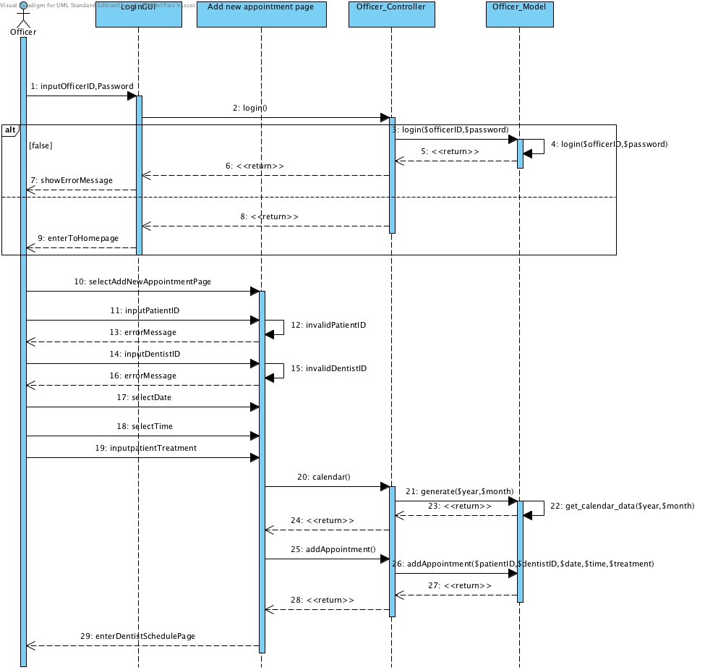

Figure 18: Officer can add new appointment into the database and it will update in the dental clinic appointment schedule

**SD-11: Officer can edit an appointment**

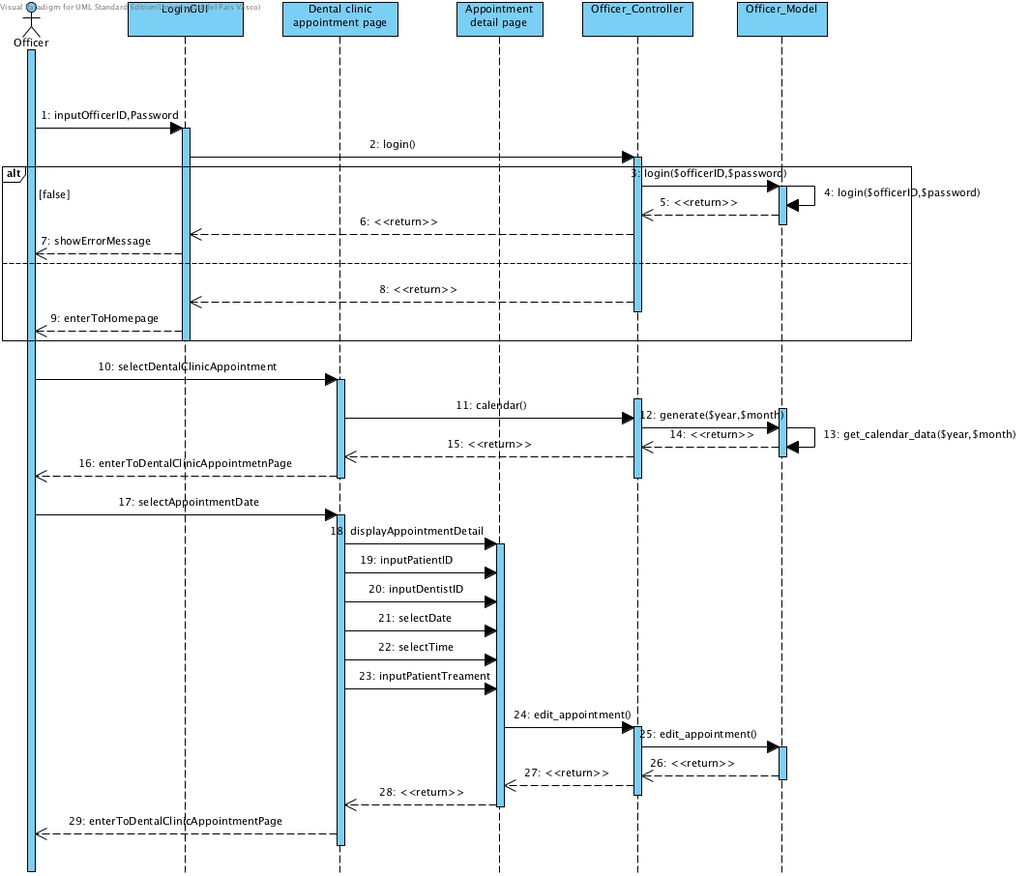

Figure 19: Officer can edit an appointment into the database and it will update in the dental clinic appointment schedule

**SD-12: Officer can delete an appointment**



Figure 20: Officer can delete an appointment into the database and it will update in the dental clinic appointment schedule

# Chapter Six: User Interface Design

## 6. User Interface Design

**6.1 Web design**

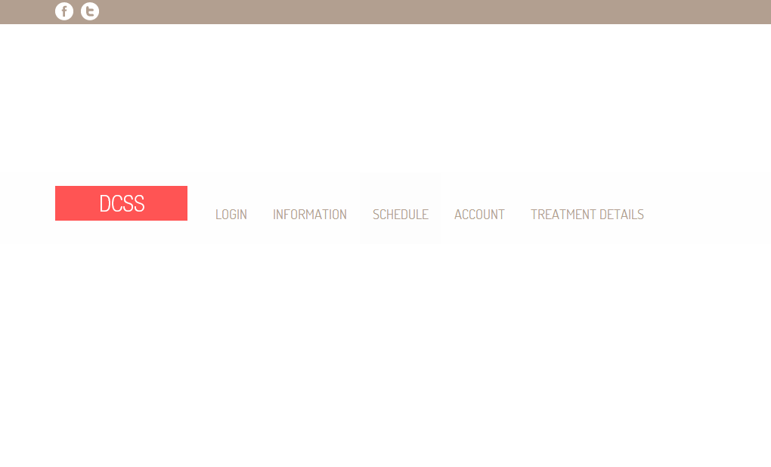

Figure 21: Shows the index page of website

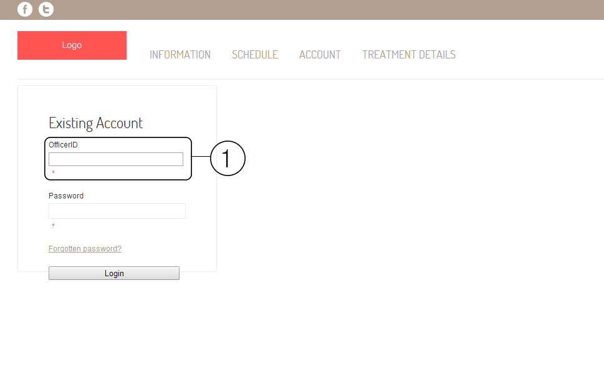

Figure 22: Shows the login page of the website. The area number 1 is the field of input userID and patientID. In officer login page will show as OfficerID, in patient login page will show as PatientID, and in dentist login page will show as DentistID.

**Patient**

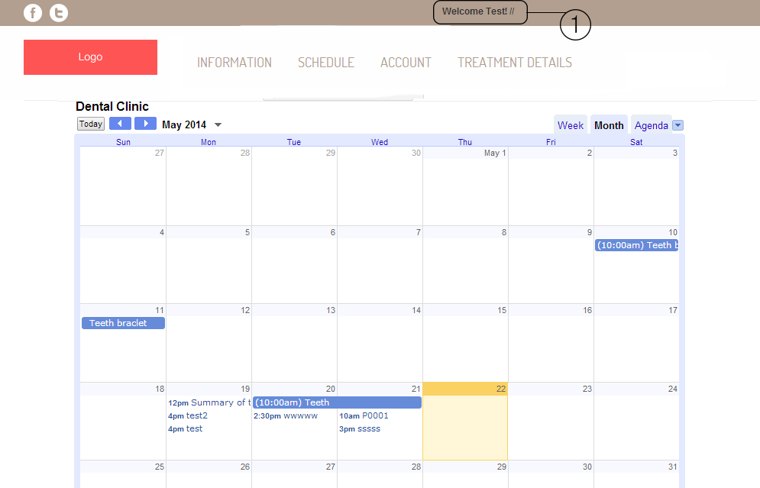

Figure 23: Shows the schedule of dental clinic from google calendar. The area number 1 will shows the name of patient.

**Officer**

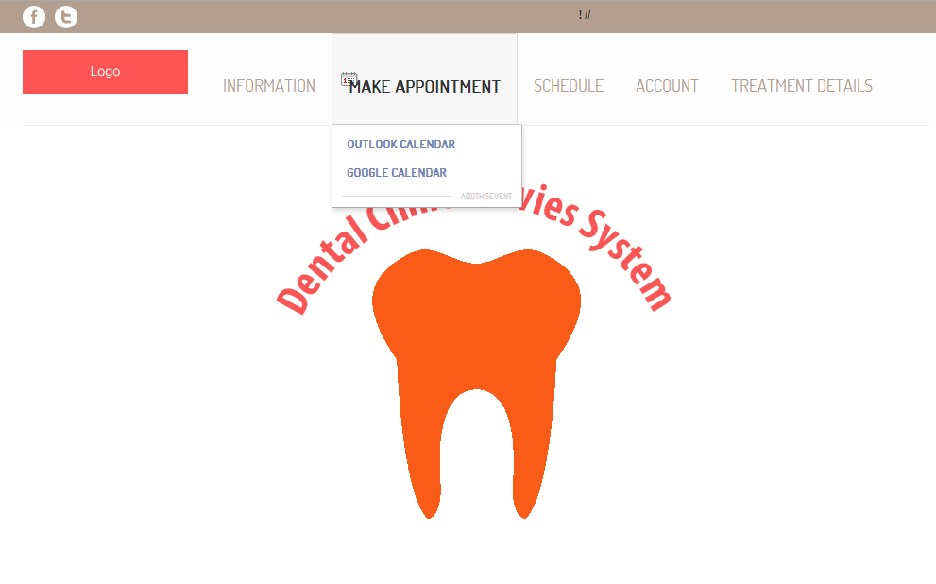

Figure 24: Shows the officer index page after officer login. Officer can make appointment google calendar, view schedule, and manage account.

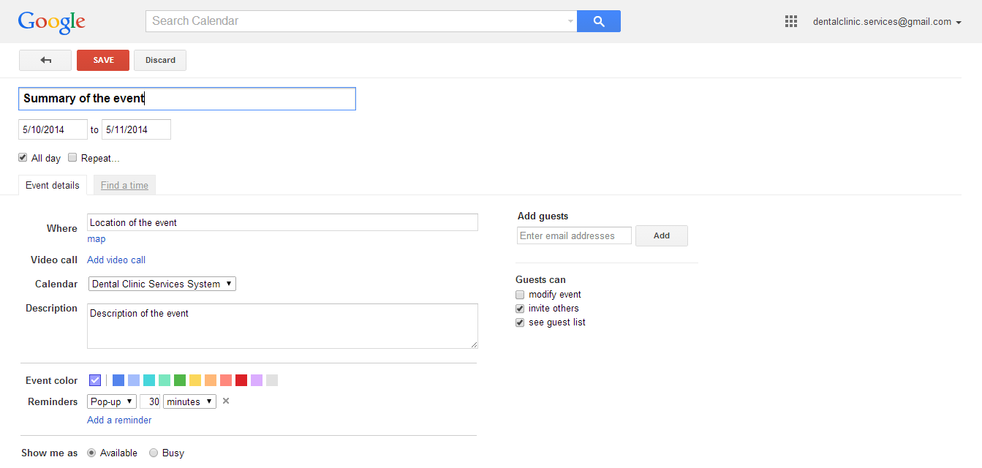

Figure 25: Shows page of google calendar to add the appointment to dental clinic calendar.

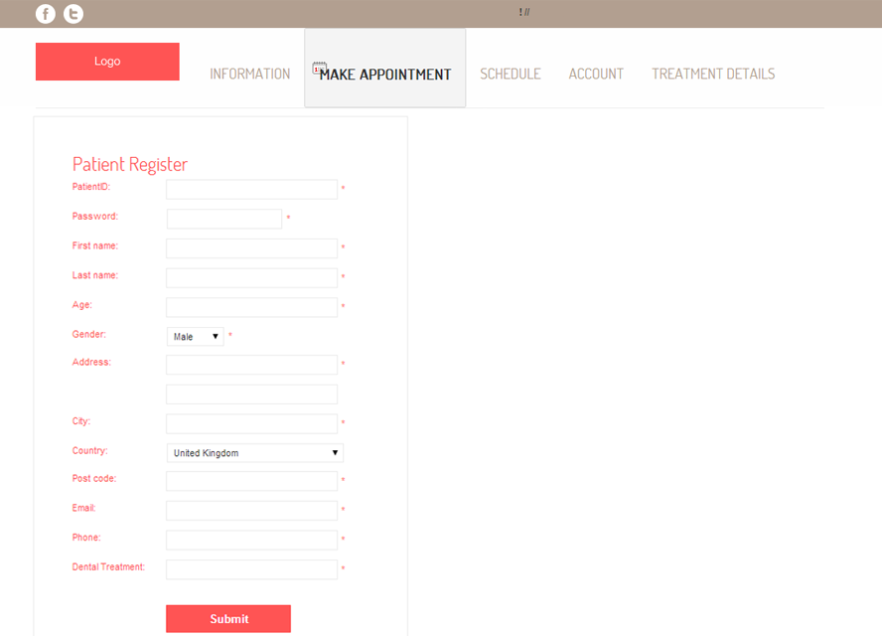

Figure 26: Shows the patient registration page.

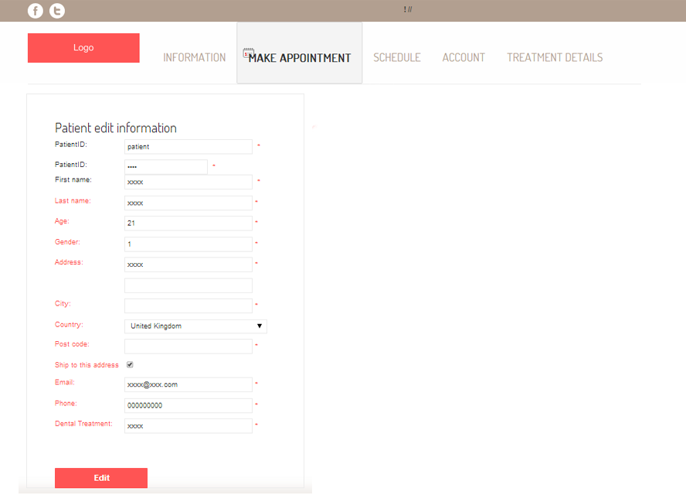

Figure 27: Shows the edit patients’ details page.

**6.2 Mobile application design**

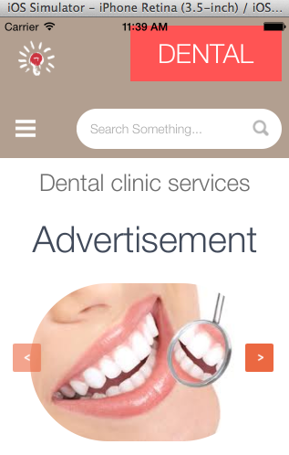

Figure 28: Mobile application home page

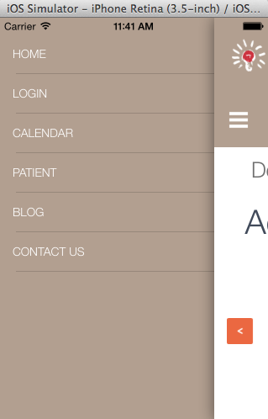

Figure 29: Mobile application menu

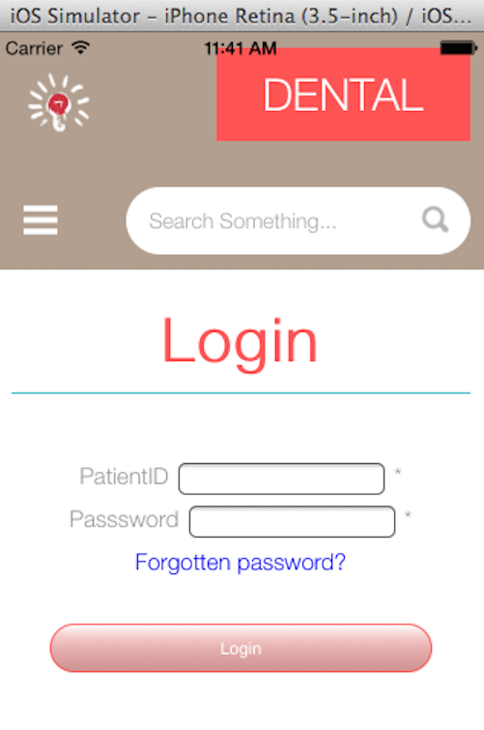

Figure 30: Login page for patient

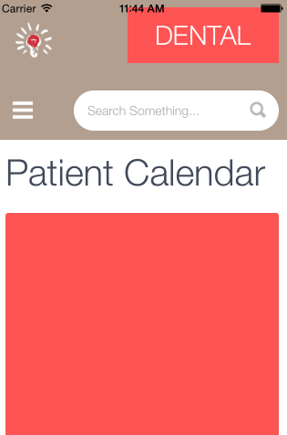

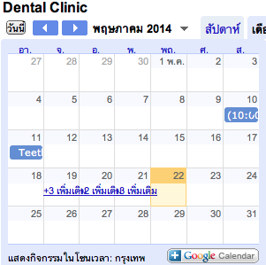

Figure 31: Patient Calendar after select patient

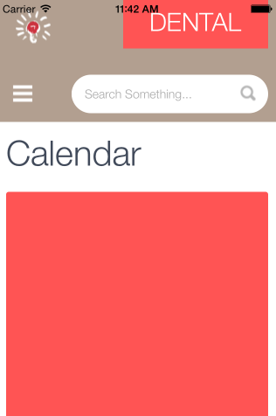



Figure 32: Dental clinic calendar